Nume proiect

____________________________________

Tip proiect (E+, eTw, SEE, etc.)

____________________________________

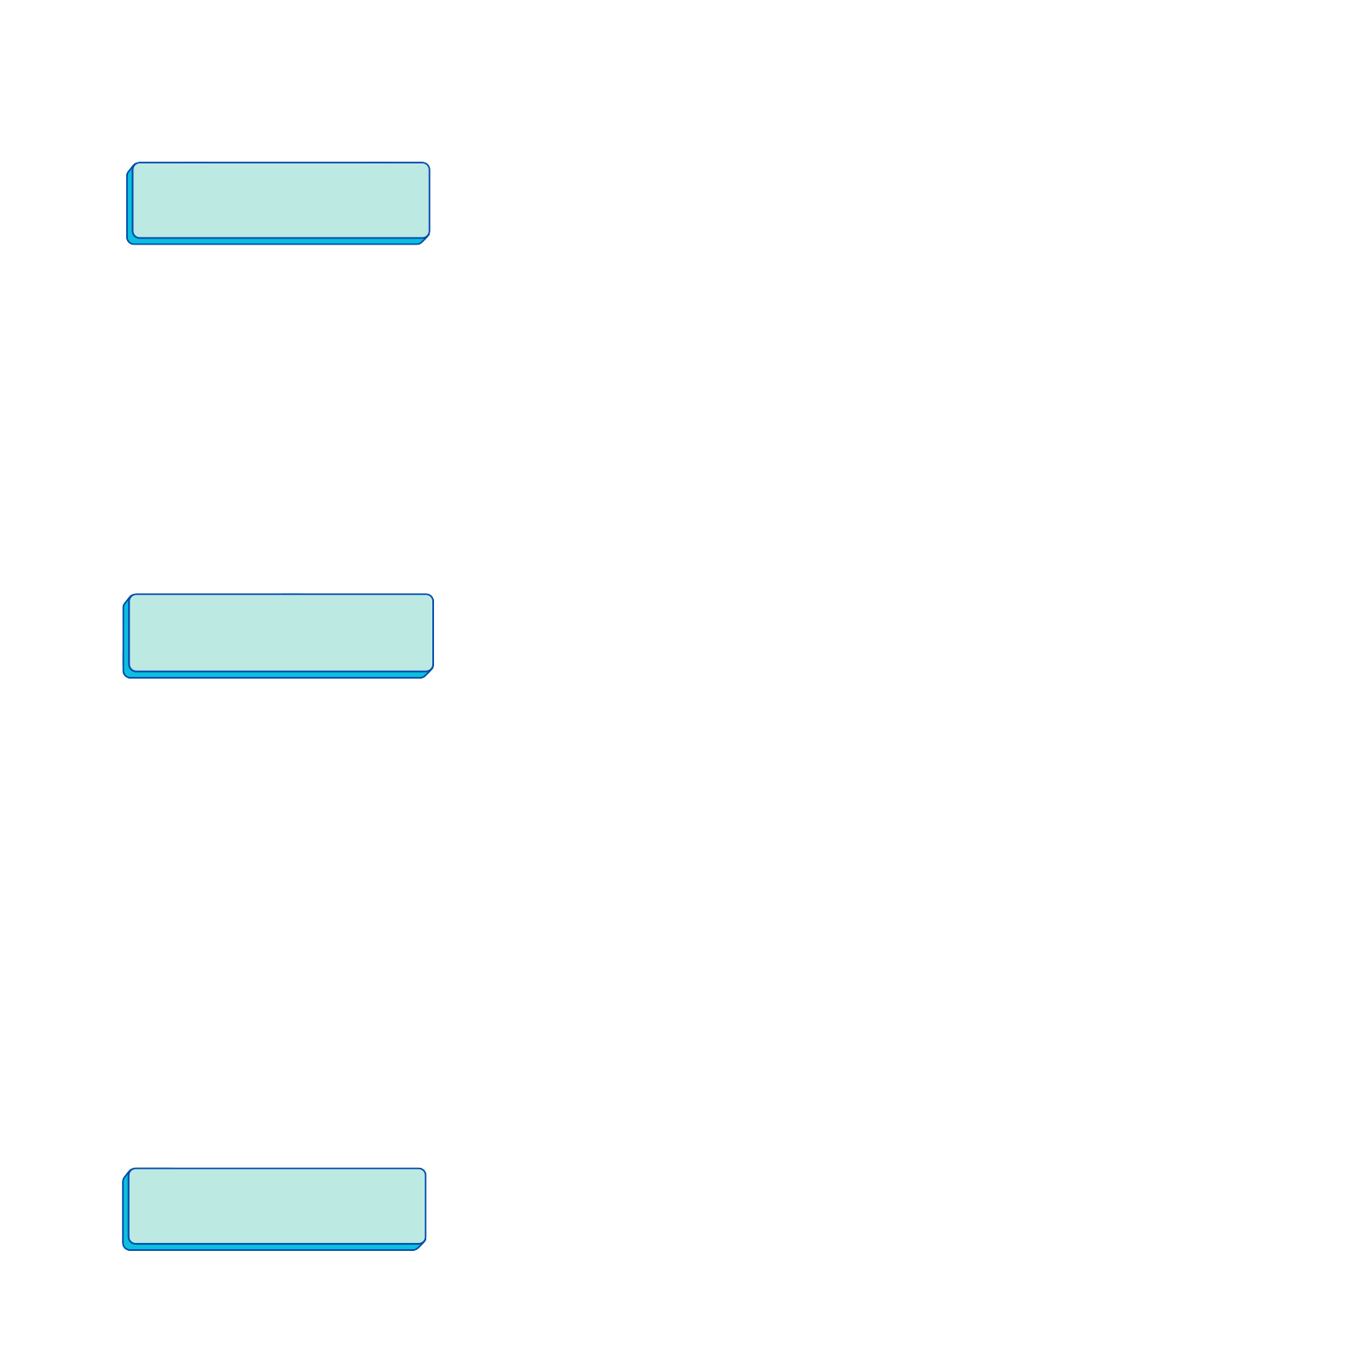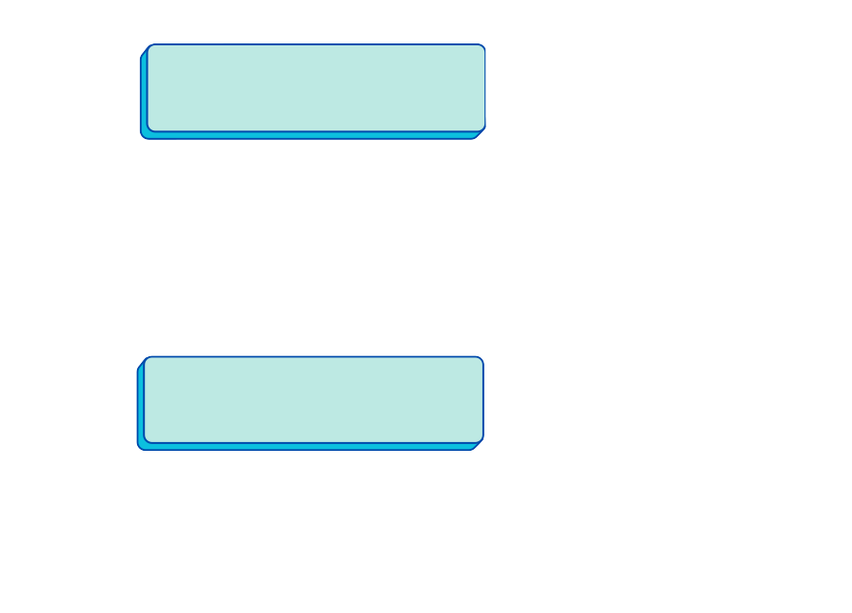_____________________________________________________________

Număr proiect

_____________________________________________________________

Rezumat

_____________________________________________________________
_____________________________________________________________
_____________________________________________________________
_____________________________________________________________
_____________________________________________________________
_____________________________________________________________
_____________________________________________________________
_____________________________________________________________
_____________________________________________________________
_____________________________________________________________

Rezultate
_____________________________________________________________
_____________________________________________________________
_____________________________________________________________

Parteneri

_____________________________________________________________
_____________________________________________________________
_____________________________________________________________

Link-uri / Website-uri
_____________________________________________________________
_____________________________________________________________

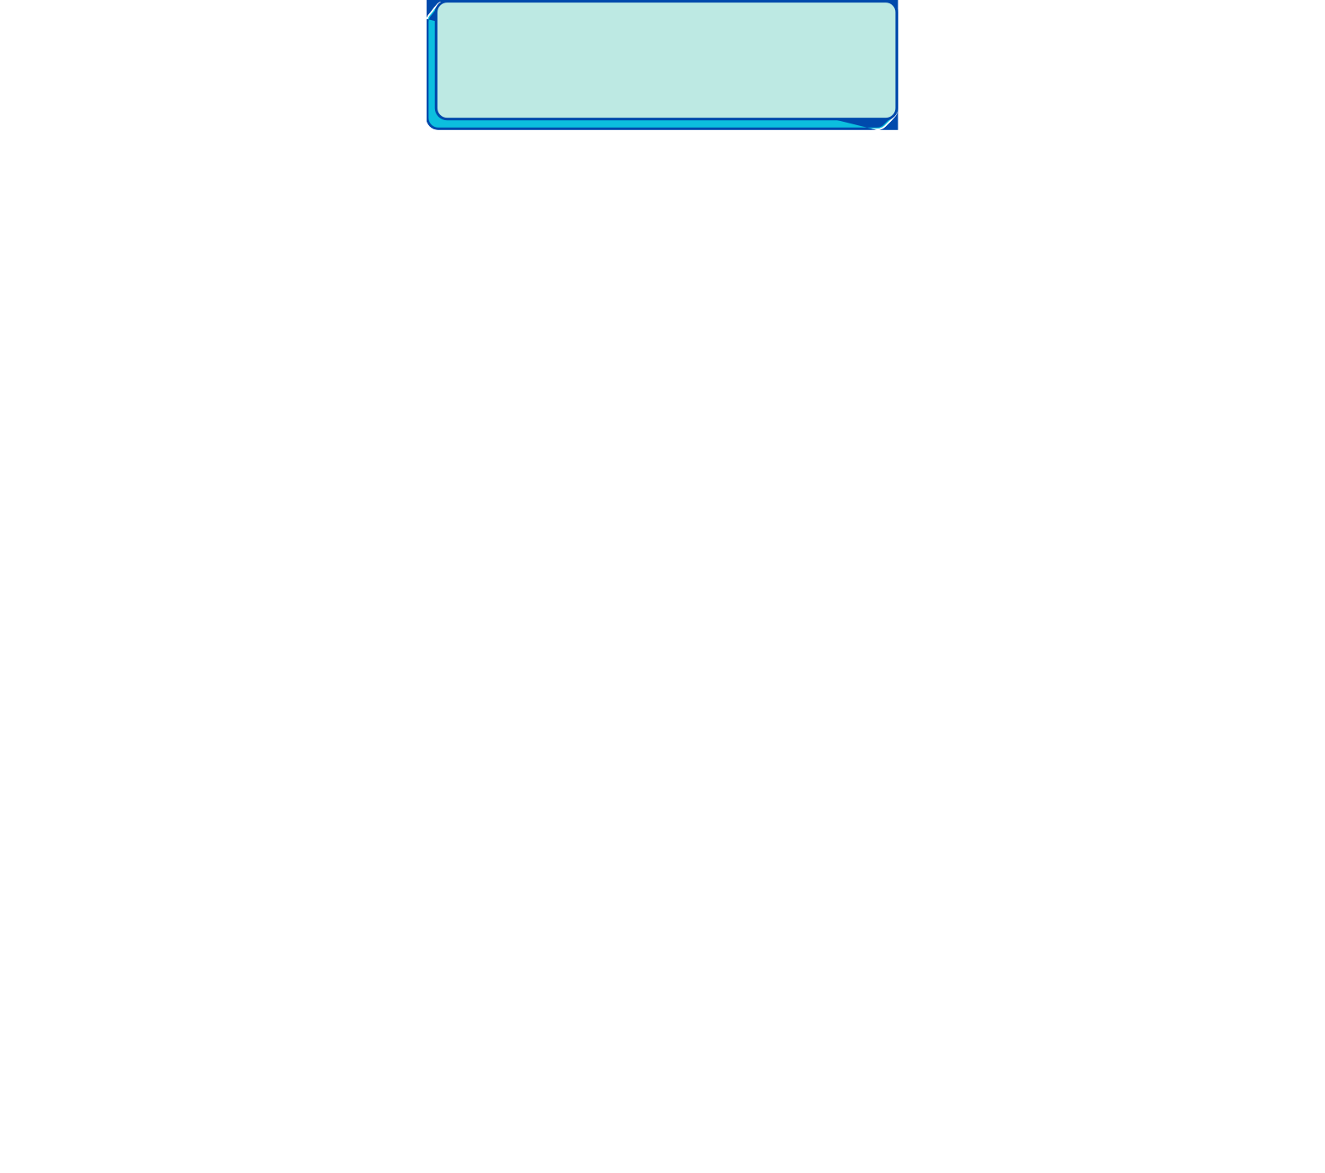Galerie foto

